PS C:\Users\zarif\OneDrive\Desktop\Programming\CSE-3106\Day 8\In Lab> uv run .\main.py
─────────────────── Memory Allocation Simulator with Fragmentation Analysis ──────────────────────
Enter memory block sizes (e.g., 100,500,200,300,600):
Input cannot be empty.
Enter memory block sizes (e.g., 100,500,200,300,600): 100,500,200,300,600
Enter process sizes (e.g., 212,417,112,426): 212,417,112,426
Select an allocation algorithm:
1. First Fit
2. Best Fit
3. Worst Fit
4. Next Fit
Enter your choice (1-4) [1/2/3/4] (2): 1
─────────────────────────────────────── First Fit – Results ──────────────────────────────────────
Allocation Details
┏━━━━━━━━━┳━━━━━━┳━━━━━━━━━┳━━━━━━━━━━━━━━━┓
┃ Process ┃ Size ┃ Block ┃ Status ┃
┡━━━━━━━━━╇━━━━━━╇━━━━━━━━━╇━━━━━━━━━━━━━━━┩
│ P0 │ 212 │ Block 1 │ Allocated │
│ P1 │ 417 │ Block 4 │ Allocated │
│ P2 │ 112 │ Block 1 │ Allocated │
│ P3 │ 426 │ — │ Not Allocated │
└─────────┴──────┴─────────┴───────────────┘
Fragmentation Analysis
┌─────────────────────────┬────────────────────────────────────────────────────────────────────┐
│ Total Memory: │ 1700 │
│ Allocated Memory: │ 741 │
│ Unused Memory: │ 959 │
│ Internal Fragmentation: │ 359 │
│ External Fragmentation: │ 959 │
│ Note: │ Internal = wasted in allocated blocks; External = total free space │
└─────────────────────────┴────────────────────────────────────────────────────────────────────┘

Generating memory layout visualization…

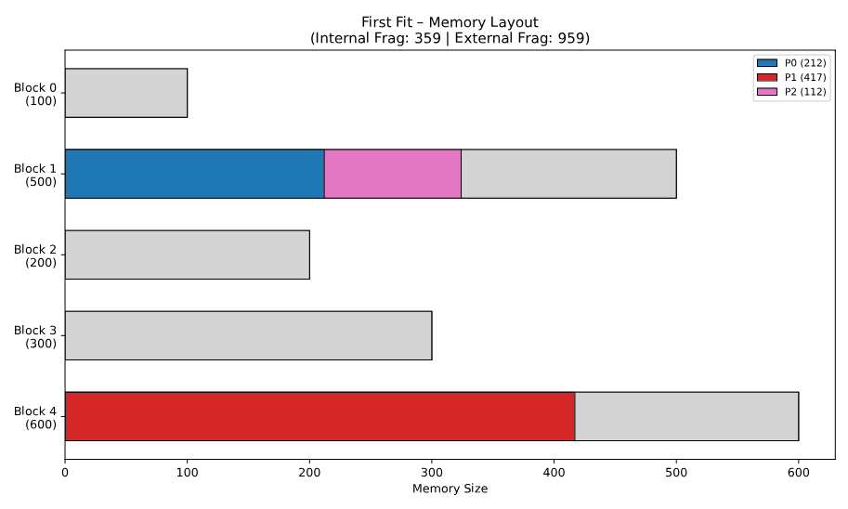
PS C:\Users\zarif\OneDrive\Desktop\Programming\CSE-3106\Day 8\In Lab> uv run .\main.py
─────────────── Memory Allocation Simulator with Fragmentation Analysis ──────────────────────────
Enter memory block sizes (e.g., 100,500,200,300,600): 100,500,200,300,600
Enter process sizes (e.g., 212,417,112,426): 212,417,112,426
Select an allocation algorithm:
1. First Fit
2. Best Fit
3. Worst Fit
4. Next Fit
Enter your choice (1-4) [1/2/3/4] (2): 2
───────────────────────────────────── Best Fit – Results ─────────────────────────────────────────
Allocation Details
┏━━━━━━━━━┳━━━━━━┳━━━━━━━━━┳━━━━━━━━━━━┓
┃ Process ┃ Size ┃ Block ┃ Status ┃
┡━━━━━━━━━╇━━━━━━╇━━━━━━━━━╇━━━━━━━━━━━┩
│ P0 │ 212 │ Block 3 │ Allocated │
│ P1 │ 417 │ Block 1 │ Allocated │
│ P2 │ 112 │ Block 2 │ Allocated │
│ P3 │ 426 │ Block 4 │ Allocated │
└─────────┴──────┴─────────┴───────────┘
Fragmentation Analysis
┌─────────────────────────┬────────────────────────────────────────────────────────────────────┐
│ Total Memory: │ 1700 │
│ Allocated Memory: │ 1167 │
│ Unused Memory: │ 533 │
│ Internal Fragmentation: │ 433 │
│ External Fragmentation: │ 533 │
│ Note: │ Internal = wasted in allocated blocks; External = total free space │
└─────────────────────────┴────────────────────────────────────────────────────────────────────┘

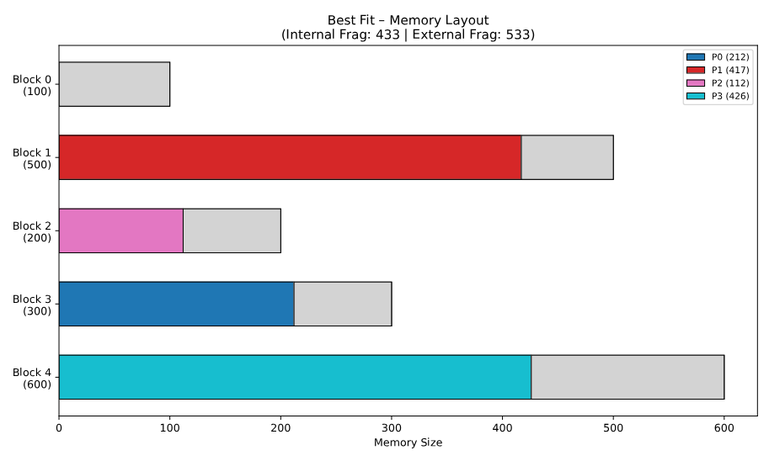
Generating memory layout visualization…

PS C:\Users\zarif\OneDrive\Desktop\Programming\CSE-3106\Day 8\In Lab> uv run .\main.py
─────────────────── Memory Allocation Simulator with Fragmentation Analysis ──────────────────────
Enter memory block sizes (e.g., 100,500,200,300,600): 100,500,200,300,600
Enter process sizes (e.g., 212,417,112,426): 212,417,112,426
Select an allocation algorithm:
1. First Fit
2. Best Fit
3. Worst Fit
4. Next Fit
Enter your choice (1-4) [1/2/3/4] (2): 3

──────────────────────────────────── Worst Fit – Results ────────────────────────────────────────
Allocation Details
┏━━━━━━━━━┳━━━━━━┳━━━━━━━━━┳━━━━━━━━━━━━━━━┓
┃ Process ┃ Size ┃ Block ┃ Status ┃
┡━━━━━━━━━╇━━━━━━╇━━━━━━━━━╇━━━━━━━━━━━━━━━┩
│ P0 │ 212 │ Block 4 │ Allocated │
│ P1 │ 417 │ Block 1 │ Allocated │
│ P2 │ 112 │ Block 4 │ Allocated │
│ P3 │ 426 │ — │ Not Allocated │
└─────────┴──────┴─────────┴───────────────┘

Fragmentation Analysis
┌─────────────────────────┬────────────────────────────────────────────────────────────────────┐
│ Total Memory: │ 1700 │
│ Allocated Memory: │ 741 │
│ Unused Memory: │ 959 │
│ Internal Fragmentation: │ 359 │
│ External Fragmentation: │ 959 │
│ Note: │ Internal = wasted in allocated blocks; External = total free space │
└─────────────────────────┴────────────────────────────────────────────────────────────────────┘

Generating memory layout visualization…
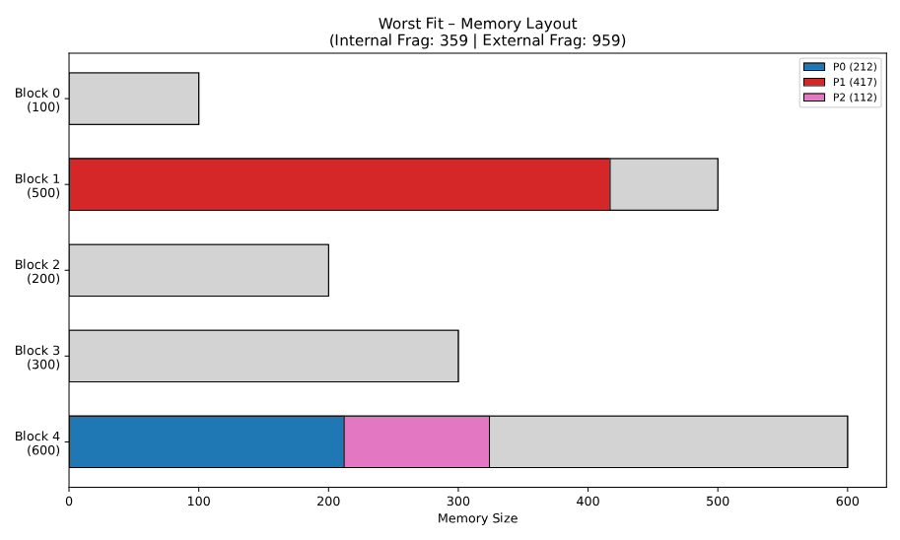

PS C:\Users\zarif\OneDrive\Desktop\Programming\CSE-3106\Day 8\In Lab> uv run .\main.py
────────────────── Memory Allocation Simulator with Fragmentation Analysis ──────────────────────
Enter memory block sizes (e.g., 100,500,200,300,600): 100,500,200,300,600
Enter process sizes (e.g., 212,417,112,426): 212,417,112,426
Select an allocation algorithm:
1. First Fit
2. Best Fit
3. Worst Fit
4. Next Fit
Enter your choice (1-4) [1/2/3/4] (2): 4
──────────────────────────────────── Next Fit – Results ─────────────────────────────────────────
Allocation Details
┏━━━━━━━━━┳━━━━━━┳━━━━━━━━━┳━━━━━━━━━━━━━━━┓
┃ Process ┃ Size ┃ Block ┃ Status ┃
┡━━━━━━━━━╇━━━━━━╇━━━━━━━━━╇━━━━━━━━━━━━━━━┩
│ P0 │ 212 │ Block 1 │ Allocated │
│ P1 │ 417 │ Block 4 │ Allocated │
│ P2 │ 112 │ Block 1 │ Allocated │
│ P3 │ 426 │ — │ Not Allocated │
└─────────┴──────┴─────────┴───────────────┘
Fragmentation Analysis
┌─────────────────────────┬────────────────────────────────────────────────────────────────────┐
│ Total Memory: │ 1700 │
│ Allocated Memory: │ 741 │
│ Unused Memory: │ 959 │
│ Internal Fragmentation: │ 359 │
│ External Fragmentation: │ 959 │
│ Note: │ Internal = wasted in allocated blocks; External = total free space │
└─────────────────────────┴────────────────────────────────────────────────────────────────────┘

Generating memory layout visualization…

